Bugs

1. RFQ # is not editable now which is good. It should be slightly gray or some nice color to signify that it is not editable and you should not be able to click in it.

2. Line is not editable now which is good. It should be slightly gray or some nice color to signify that it is not editable and you should not be able to click in it. The line # should actually start at 1 for each new RFQ. Think of it as a purchase order with multiple line items starting at #1 and going to ....

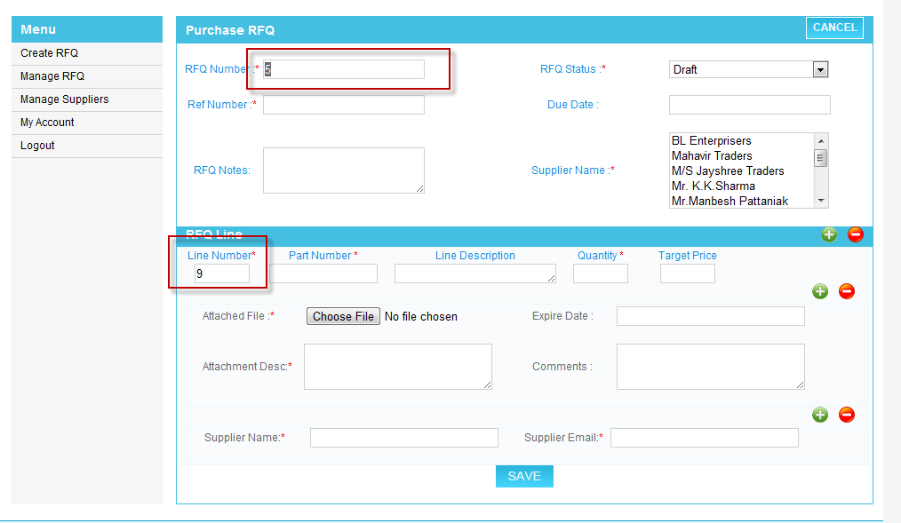

3. The supplier list box may not work too well because we have customers that could have a list of 2000 suppliers. Make it so it suppliers can be searched, hit a + button to add more suppliers. This is where some of the confusion comes in.

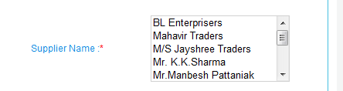

As shown below you can add multiple suppliers per line item which is good . We probably don't need the supplier list at the RFQ header, we just need to be able to select, search and grab existing suppliers or type in suppliers directly as shown below. If you add suppliers at the line item level, if you add another line item, copy all the suppliers from the previous line item. This would eliminate the need to select suppliers at the header.

NOTE : I had in the RFQ header the BuyerFK, this should be removed, its not correct.

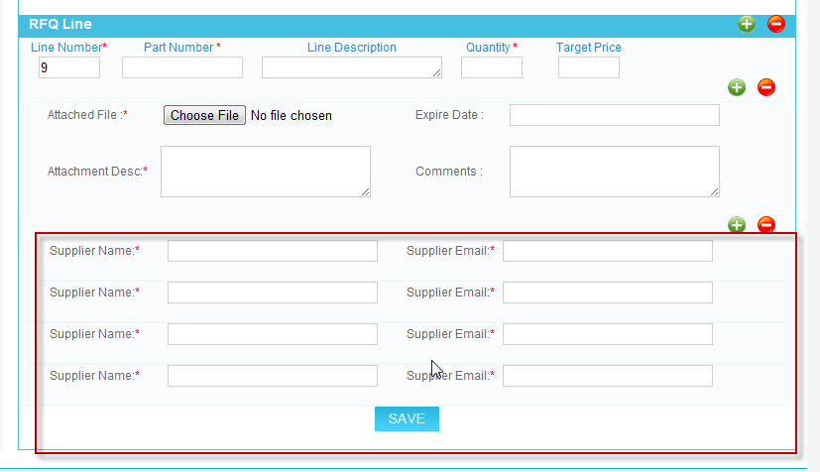

3. If there is no attachment, the attachment description should not be required.

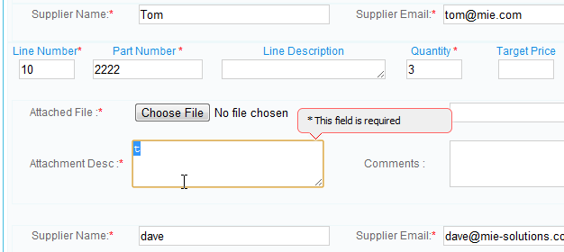

4. a. The save did not work in this situation.

b. Ask Y/N to delete items versus just deleting

c. Mabey you would want to make the attached files are and the supplier area below like the line & part number row. Screen is less "cluttered" with the same text repeated over and over. You may have a better idea.

**Attached File Expire Date Attachment Description Comments**

[xxxxxxxx] ..................................

**Supplier Name Supplier Email**

[xxxxxxxx] dave@...

[yyyyyyyy] tom@...

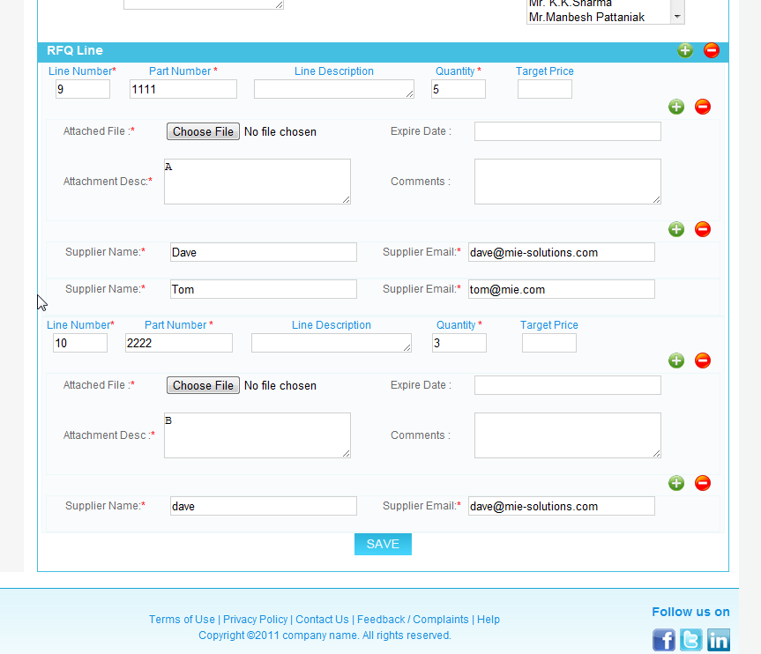

5. One of the goals is to be able to compare prices of suppliers. Your existing VIEW RFQ screen is shown below

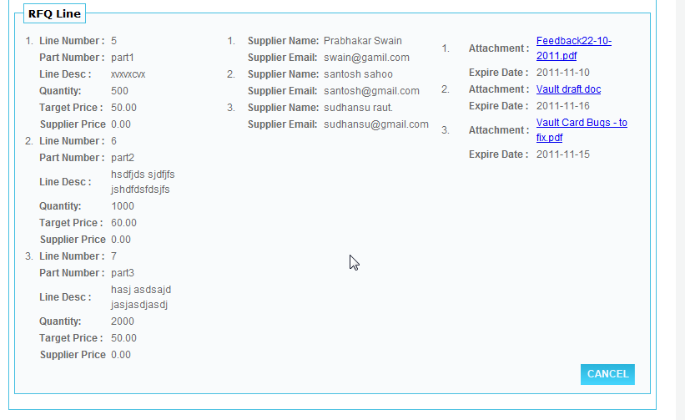

My example so prices could be compared, etc would be like this. This way the Buyer who submitted the RFQ would be able to compare all the prices from each supplier in a nice and easy screen. In the current screen I cannot see how you would be able to view the supplier responses. You can put the attachments someplace, not exactly sure. Mabey just a button to open the attachment next to each line item. When clicked it lists all the attachments which you can then view.

|  |  |  |  |  |  |  |  |  |
| --- | --- | --- | --- | --- | --- | --- | --- | --- |
| Line | P/N | Description | Quantity | Target | Supplier | Status | Price |  |
| 1 | PART1 | XXXXX | 500 | 50 | Prabhaker Swain | Bid *Submitted* | $45.00 |  |
|  |  |  |  |  | Santosh Sahoo | Bid Submitted | $65.00 |  |
|  |  |  |  |  | sudhansu raut | Bid Submitted | $40.00 |  |
| 2 | Part2 | yyyyy | 1000 | 60 | Prabhaker Swain | Bid Submitted | $100.00 |  |
|  |  |  |  |  | Santosh Sahoo | Bid Submitted | $35.00 |  |
|  |  |  |  |  | sudhansu raut | No Bid | $0.00 |  |

Questions :

1. Now supplier list box is removed from the RFQ header. And multiple supplier can be added at line level. So I cannot clear about the searching of supplier while creating RFQ. Plz clarify it again?
2. Is it necessary to copy the supplier name while adding next line?. It will be difficult to identify the supplier text ids in next line level as these are dynamically generated.
3. Buyer FK is inserted internally at the time of creating RFQ. So is it necessary to show the BuyerFK at the RFQ header? If so, then we will so the buyer name (not Id)at the RFQ header.
4. Plz clarify in which screen Tabbing system of Line items and suppliers will be implements.(mentioned in first bug report).

Answers:

#1. You have the ability to type in the supplier name and email at the line level which is good.  This would add the supplier to the RFQ on the fly.   If you have 1000 suppliers in your list of suppliers you manage we need a nice way to find the supplier so it populates the supplier name, email and supplier FK easily because when a dropdown list box becomes thousands of items its not easy to select.  Mabey bring up a find dialog that lets you search and filter your supplier list in order to select 1.  This can be enhanced further in phase 2 to have 'groups' of suppliers, or most recently used suppliers, etc.  
  
  
#2. The idea is each set of lines can be sent to different suppliers.  I know that is not a very good plan but I was trying to make it easier on development because each supplier needs to respond to each line.  This is the ugliest part to develop because we have to think in advance that there will be suppliers added or removed during the submit, response and resubmit, response workflow.   We need to talk about this because the main idea we need each line going to each supplier, so each supplier can resond independently with their specific prices.  Mabey we should of had the table  
  
RFQLine relates to RFQLineSupplier and the RFQLineSupplier relates to RFQSupplier and contains the price response from the supplier.  (If you did it this way, that would be ok but I'm not sure how you actually implemented)  
  
#3. Supplier does not need to be in the header, so that is ok.  (Each line item has its list of suppliers as stated in #2)  
  
#4.  Not sure here.

Thanks for the update, its looking better each day.  Here are a few bugs I found just as I was quickly taking a look.  I'll look more later  
  
1. Email sent to supplier, clicking on the link shows the wrong RFQ  
  
2. Email should have more contact information who it was from, etc.  
  
3. Big issue - When a supplier clicks on the link from the email, only that supplier's pricing should show up, not all suppliers.  A supplier should not be able to see any other suppliers results.   Only the buyer see's everything.  
  
4. When buyer submits, the status on the RFQ should be submitted.  
  
We'll work on workflow stuff as we move forward.  
  
I'll test some more later.